Teacher Hanna Brown
Grade / Class 5th / Art
Lesson Title City Scape from Scratch
Big Idea Community

Key Concept
Students at the Emerging Expertise age (9-11 years old) is when they are starting to refine their skills in art referred to Dawning Realism where they have a dissatisfaction with art when it is represented as schema that they see in their every day life. Now, the students want to accomplish that task by creating something they aren’t dissatisfied in. At this age they are aware of proportion and perspective so creating a cityscape was the best subject for their visual skills. The cognitive development of these learners are fitting into the peer group agendas and think logically and flexibly for solutions to a problem, so having 5th grade collaborate together to create a building as a group also plays into the idea of community. They have a larger awareness of this age where they can comprehend needing to accommodate to others by creating their own proposal.

Essential Questions
- How does your community impact a mural?
- What is color theory? (& How do we use it?)

National / State Standards
VA: Cr1.1.5a Combine ideas to generate an innovative idea for art-making
VA:Cr1.2.5a Identify and demonstrate diverse methods of artistic investigation to choose an approach for beginning a work of art.
VA:Cr2.3.5a Identify, describe, and visually document places and/or objects of personal significance
VA:Cn10.1.5a Apply formal and conceptual vocabularies of art and design to view surroundings in new ways through art making.
VA:Cn11.1.5a Identify how art is used to inform or change believes, values or behaviors of an individual or society.

Lesson Objective
- Students will synthesize their knowledge of murals and community to make their own building as a team from “scratch” by assigning roles, documenting, and formulating a proposal.
- Students will create their proposal building for the “City-from-scratch” using cardboard and paint, when they have finished as a class they will collaborate to position their buildings in the mural with the other 5th grade classes.

Assessment I will have an index of which students listen during the PowerPoint, participate in discussion, and are collaborating with their group art through out the class period. I will be grading on working well with others, participation in the project, and completing their role in the group. At this school students 1st-5th are graded on a (^, #, *) rating scale meaning: progress needed, meets expectations, and above expectations. Students will also fill out a peer evaluation form to see how well they are and their peers were acting as a group.

Media Category / Materials List
Cardboard
Paper
Pencils
Scissors
Paint
Brushes
Water
Worksheet
Sharpies
Tape

Lesson Overview (brief paragraph, quick description of the lesson)
Students will use technology and iPads to take a pre assessment quiz together about murals and color theory. Students will use Habit 6: Synergize to work together to start their own building “from scratch.” The prompt will be a city needs to be built, what are the necessary services and extra services a city can provide, your group needs to make a proposal just like they would for murals in real life. Students must work together to assign jobs, prepare for sick days, and create the work. When students finish their proposal written part they will present to the class their idea and a board of helpers will approve the idea. Students who have been approved will sketch their idea and the following day cut out cardboard and paints to assemble their building.

Procedures
Day 1
05-10: Students play kahoot/pre-assessment
15-25: Students watch and graffiti board the Ted talk video
- What does community mean to these people? Jot down what was important and stuck out to you in the video
25-30: Teacher-student discussion and questions about murals and community
35: PowerPoint example of other murals, start a city from scratch, and proposal
40: Assign groups with are by color table, jobs should be assigned and who takes the job when that person is missing
45: Students be completing proposal and sketching out building
40: IF THIS GOES FASTER THAN PLANNED each table with read aloud their proposal they will plan for their cityscape, no one can do the same building, first come first serve.
50: Talk about color families and needing to pick 3 that are related, if you need a fourth you have to argue why your “organization” needs this material just like an actual proposal. Must be approved by the teacher and fictitious “board” for extra funds.
55: Clean up and review for next time.

Day 2
05-10: Review with students about community, cities from scratch what is important to that community, and proposal jobs.
10: Students will start with cardboard and sharpie to outline which areas are what color and have their proposal approved by Ms Brown
15-45 : Each student should be participating in making their building. Cutting, tracing painting, gluing.
50: Building should be finished and drying, review for next time.

Resources

https://www.ted.com/talks/haas_hahn_how_painting_can_transform_communities
Graffiti boards

https://www.muralarts.org/about/apply-for-a-mural/
How to apply for mural/proposal ideas

https://www.muralarts.org
Mural arts many mural images

http://inspireart.org/en/resources/communityart/
Community art article.

http://www.tigercolor.com/color-lab/color-theory/color-harmonies.htm
Color theory images/ideas
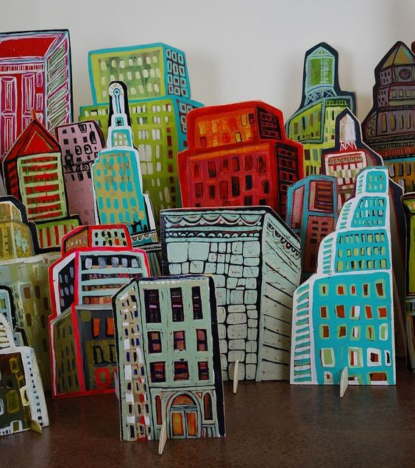
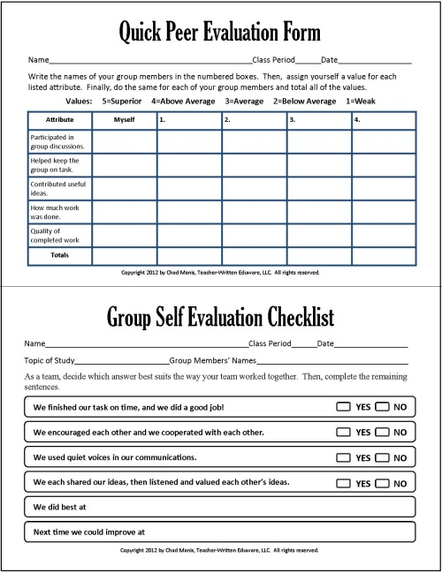

Notes for myself

create your own building/neighborhood and how that organization gives back to the community
how do we give back to the community as leaders?
How does Josiah? How could we give back to our parents, our teachers, our environment as in grass, police officers, people who help keep us safe and educate us?

Plan on a piece of paper scale, colors before hand

Everyone at the table needs a role
Everyone needs to participate in the making of it
How large the material is
4 roles defined by you
Proposal ideas of ideas of community in their school
Drawing of how that is made
Can use iPad for inspiration

Present to the class, how your building is a part of community, or how they give back to the community

Community a place where people can come together to do shared interests at.
Community center-gym
Park
Lake
School
Class
Your culture

Parts of a mural
A message to the people
Empowerment
Civic pride
Neighborhood beautification

Make buildings
Flowers
Public art
Addresses a social issue?

