Instructor Hanna Brown
Grade/Course Visual Art/4th Grade

Lesson Plan Everyday Heroes/Role Model Collage
Key concepts Understanding how others have different life experiences than us because the color of their skin. Being an ally to those who are treated unequally. Students will understand how to listen empathetically and advocate for those who are treated unequally.
Media category/Materials Digital/Mixed media collage. Materials include Google Slides, paper, markers, scissors, magazines, glue, cardstock, paint, pencils, and sharpies.
Lesson Overview
Racism has always been a prevalent issue, this past year (2020) has introduced a lot of protests that students are impacted by. Either older siblings may face these issues or themselves even at a young age. Kansas City had their own Black Lives Matter protest and BLM road murals, so this issue does matter to the students I teach. Students will either be introduced to the idea of race or racism or they are already familiar with it. We will discuss how some of our classmates are treated different because they were born with a different color of skin, something they can not change.
We are going to learn about several black heroes from this video on PBS kids (https://www.pbs.org/parents/talking-about-racism) and a PowerPoint that I have created. Students will get to explore the PowerPoint on their iPad to learn about the injustices that people of color faced and how this everyday hero helped fight against racism. We will look at Ruby Marquez’s artwork to create our own local hero to make a digital (or physical) collage. We will review and record why we chose this hero and what work they did to display a QR code next to our artwork in the hallway. We will use this to discuss with our classmates and our families.
Activity 1
Essential questions:
What is racism? Why is it bad to treat people different because of their skin color or something they can not change? How do people contribute to awareness and understanding of their lives and lives of their communities?
Standard:
Cn.11.1.4a Through observation, infer information about time, place, and culture in which a work of art was created.
Objectives:
Elementary students will discuss as a class what racism is and how others have experienced being mistreated because the color of their skin; they will understand how we treat one another matters.
Instruction:
Students will watch the PBS kids video on race and racism (clipped smaller so it will be closer to 10 min). Students will participate in a teacher-student discussion about what is race? What is racism? Why do you think they were treated unfairly?
We will use the article from Kid’s Health to use every day examples:
School-age kids: Use practical examples from everyday life to help school-age kids understand how they might feel if they're discriminated against or left out on purpose. Something like, "How would you feel if someone held on to all the swings during recess and didn't give any other kids a turn?" Or, "How would you feel if you saw a fifth-grader bullying a first-grader?" Then, connect these questions to real-life examples of groups of people who have been discriminated against. Asking questions like these helps to increase kids' empathy and spark their passion to stand up for others.

Activity 2
Essential question:
What is a hero? What is a role model? Who do we see? How does Ruby Marquez’s artwork help break racist boundaries?
(from national standards: How do life experience influence the way you relate to art? How does learning about art impact how we perceive the world? What can we learn from our responses to art? How do images influence our views of the world?)
Standard:
Re.7.2.5a Identify and analyze cultural associations suggested by visual imagery.
Re.8.1.5a Interpret art by analyzing characteristics of form and structure, contextual information, subject matter, visual elements, and use of media to identify ideas and mood conveyed.
Objective:
Elementary school students will be placed in small groups to analyze and critique Marquez’s artwork. We will compare old artwork to see who was the focus then? And why are these people the focus now?
Instruction:
Students will then explore the Google Slides of artist Ruby Marquez’s work in small groups to look at who is the focus, what they see, what is the artist trying to convey. We will discuss as a whole class what students “notice.” We then will discuss the connections to race and why Ruby Marquez sees these people as heroes.

Activity 3
Essential Question:
Who is your hero? What symbols convey the work they do? How is art used to impact the views of society? How does art help us understand the lives of different times, places, and culture?
Standard:
Standard 4. Re.7.1.4a Compare responses to work of art before and after working in similar media.
Cn10.1.4a Create a work of art that reflect community cultural traditions.
Objective:
Students will create a digital collage along side the teacher by choosing their own hero from pictures and information given.
Instruction:
Demonstrate how to access the word document filled with local and national heroes. Students will get to choose their hero from this information on what they do in their community. The Instructor will demonstrate how to pull up Google slides to create their artwork influence by Ruby Marquez. Students will use their iPads to create their digital collage. Students will then discuss with their tablemates why they chose this person and what they can do that is like their personal hero.

Teacher Example
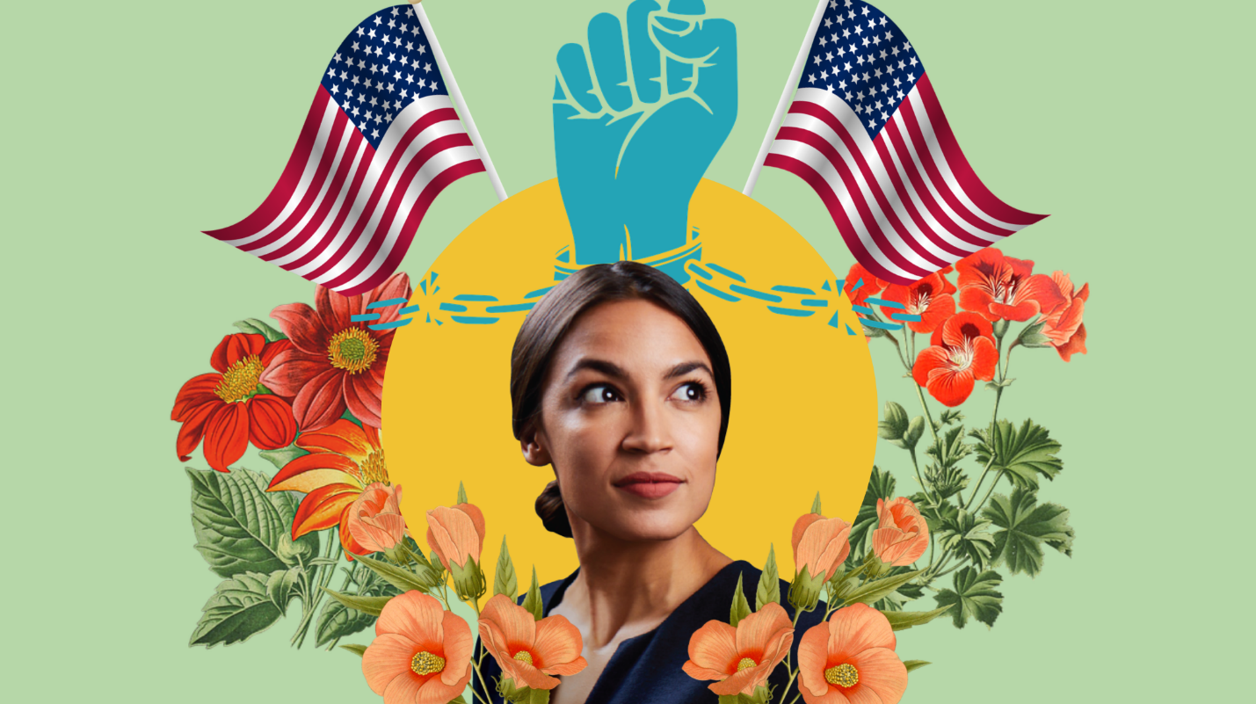
Resources
https://www.adolescent.net/a/broobs-marquez-the-sf-artist-using-collage-to-tell-stories-of-the-blm-movement
@broobs (Instagram)
https://www.broobs.online/info-contact
Don Masse, Art Instructor of Elementary Art Students. Broobs (Ruby) Marquez Art Demo https://drive.google.com/file/d/1pgJuUp2pOxPRp9icJWlZshXiIKoFOrw0/view
https://kidshealth.org/en/parents/talk-about-race.html
https://www.pbs.org/parents/talking-about-racism

