Teacher Hanna Brown
Grade/Course Middle School

Kerlevage explains that Middle school students’ (ages 11-13) cognitive development is being able to recognize three-dimensional space, which is a key component to analyzing graffiti. Some prints are seen with less to utilize the space of the art form and the negative space to make a two-dimensional space come to a three-dimensional shape. Middle school students also experiment with their medium several times before they come to a final print. Social development is impacted by thinking too much of what their peers say, so making sure that the students create and understand things with out worrying about what their peers think of them, but being able to establish themselves as individuals, but still a part of a group which is why the assignment focus’ on their generation as a whole than more focus on self-reflection. Kerlevage also explains their aesthetic development as forming to be self-expressive being able to make artistic choices by themselves is important through out this lesson.

Lesson Plan Graffiti: A Visual Culture

Key concepts Understanding how we read graffiti. Students will be able to convey how some graffiti can be seen as art, others as vandalism. Students will understand what visual culture is

Media category/Materials Printmaking/Mixed medias. Materials include X-acto knives, paper plates, tape, tracing paper, pencil, sharpies, photoshop (if necessary), paint, cotton balls, and cardstock.

Lesson Overview
Visual culture is seen in every day life. Students will be able to analyze graffiti and why it’s seen differently in different context. Not only the context in setting, but the formal and subject matter of the art form. Students will discuss why graffiti isn’t accepted in society across cultures and where they run into graffiti. Students will observe this visual culture based on thinking critically of something they see on a daily basis, but most likely ignore.
Students will then be introduced to the artist Banksy who is notorious for street art with graffiti involving political stances and satire. Students will be shown age appropriate works to analyze and conceptually look at graffiti. Students will then look create their own stencil and graffiti-like print that connects with their generation or representation of themselves. Once students finish their “graffiti” they will be assessed with the rubric attached.

Activity 1
Essential questions:
Where do you see graffiti? Where is it acceptable to use graffiti? Is it ever? What about for art?

Standard:
Responding 7. Perceive and analyze artistic work. Visual imagery influences understanding of and responses to the world.

Objectives:
Middle school students will discuss as a class what graffiti is seen from different perspectives; they will understand how graffiti impacts society and the visual art culture.

Instruction:
Students will participate in a teacher-student discussion during the PowerPoint: Graffiti: A Visual Culture. This PowerPoint will have images of traditional graffiti that students most likely come across on a regular basis. Students will be prompted with questions such as: Where do you see graffiti? What does graffiti usually display? Are there any graffiti that isn’t just names or tagging? How do police see view graffiti? How do street artists? Students should be able to communicate or learn from their classmates what graffiti is and how it’s used in our culture.

Activity 2
Essential question:
How does Bansky use color, context, and medium to convey deeper meaning?

Standard:
Creating 1: Generate and conceptualize artistic ideas and work.
Artists and designers shape artistic investigations, following or breaking with traditions in pursuit of artistic goals.

Objective:
Middle school students will we placed in small groups to analyze and critique Banksy’s work in the assignment called “Banksy’s Critique.”

Instruction:
Students will then be introduced to the artist Bansky via a series of images; students will see other art works created by Bansky and fill out a worksheet called Banksy Critique. They will be put in small groups and given a selected work from the teacher to critique (also provided in attachments). Students will analyze color choices, composition, deeper meaning, materials, etc. then present to the class their findings.

Activity 3
Essential questions:
What symbols, themes, objects, describe your generation? How does graffiti imply certain notions?

Standard:
Creating 2. Organize and develop artistic ideas and work.

Objective:
Students will create a graffiti-like print that reflects their culture and generation.

Instruction:
Students will watch a demo on how to create their stencil and make it into graffiti-like print. Students will create a stencil and make their own “graffiti” using paint and a stamping method. Students will be instructed to create a stencil that reflects their culture in their generation: it can be a symbol, person, object, place, or thing. Students will be experimenting with their medium several times before they come to a final print. Students will be assessed by originality, creativity, craftsmanship, composition and coloring. Points for effort will also be given out. Students will be graded on the rubric attached.

Extension Elementary:

The first and second activity will be combined into a PowerPoint, no worksheet included for the sake of time in a 45-minute class period. Students will view Banksy’s work and understand it critically, but not abstractly because this age group hasn’t developed the skills yet. Students at the age group of 7-9 are developing symbol making so this will be shown more in their art making activity. Students at this age are refining their hand-eye coordination in their physical development. I am unsure if it’s appropriate for them to use x-acto knives at this age, instead they could be making a stamp by cutting out shapes and gluing them in more of a printmaking form that is similar to a stencil.

Extension High School:

The same activities can apply to the high school level. Students at the high school level are motivated with activities about social issues and emotional expression. Changing the lesson worksheet to more difficult works of Banksy because students at this age can understand abstract ideas and more political stances Banksy uses. Students can use the same works from Banksy to identify deeper meanings than younger students. Students will instead select a social issue to criticize similar to Banksy in a visual culture manner. Students in high schools’ social development will improve through their group activities, small and large, with discussion and group art projects.

Resources

Kerlavage, M. (1998) Teaching meaning through art making. Accessed through BlackBoard from https://courseware.ku.edu/bbcswebdav/pid-4867368-dt-content-rid-10101482_1/courses/4159-15013/Kerlavage%20%281998%29%20Understanding%20the%20Learner%20%28complete%29.pdf.

https://en.wikipedia.org/wiki/Graffiti

Rubric website.
http://www.coronetpublications.net/tag/art-lesson-rubric-template

Images from Banksy for worksheet.
http://banksystreetart.tumblr.com

Images from Banksy.
http://www.smithsonianmag.com/arts-culture/the-story-behind-banksy-4310304/?no-ist

“How to cut a stencil: Easily”
https://www.youtube.com/watch?v=yHsojM5d5no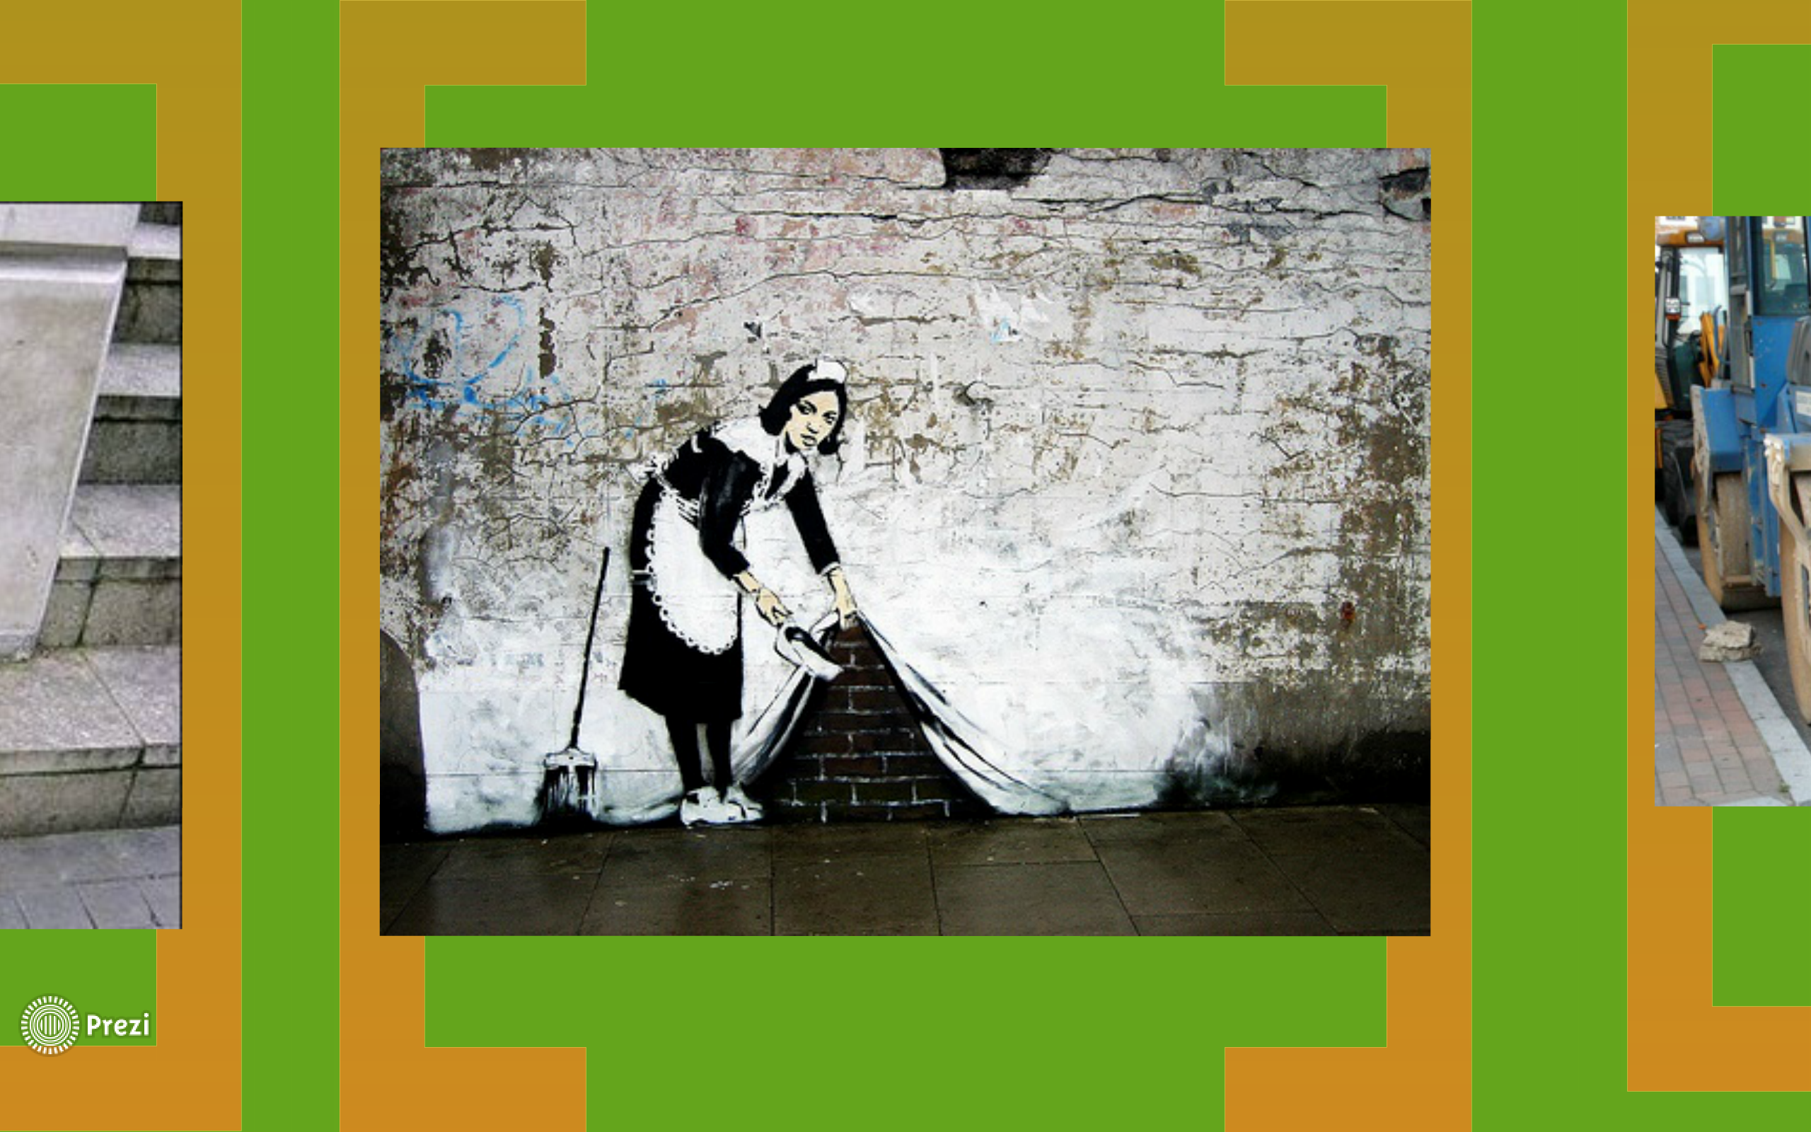

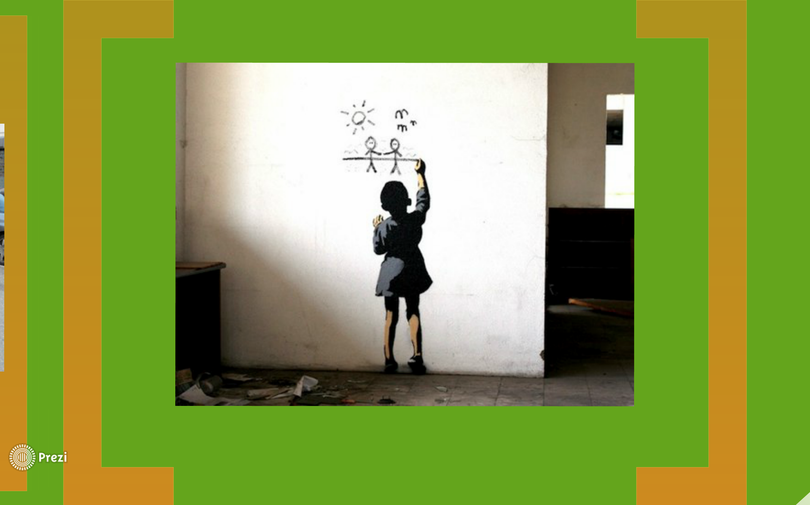

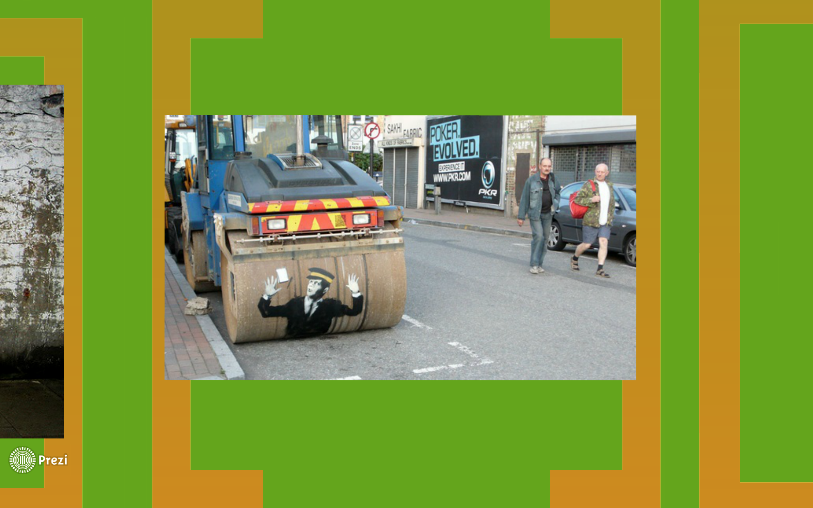

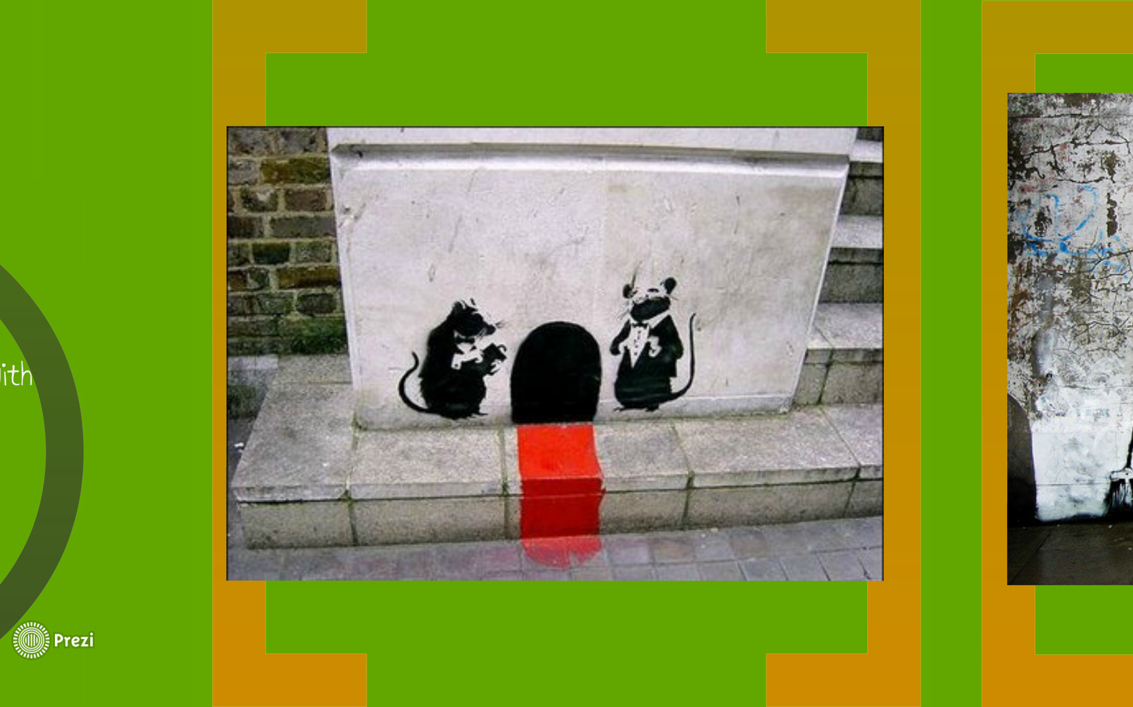

Prezi from Holly Elizabeth about Banksy.
https://prezi.com/rph0q3e6bjzy/banksy-lesson-plan-visual-culture-street-art/

BANKSY CRITIQUE
Group 1
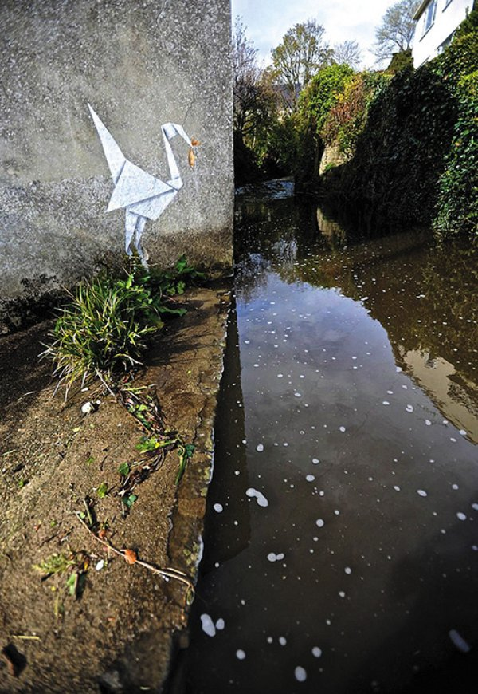
BANKSY CRITIQUE
Group 2

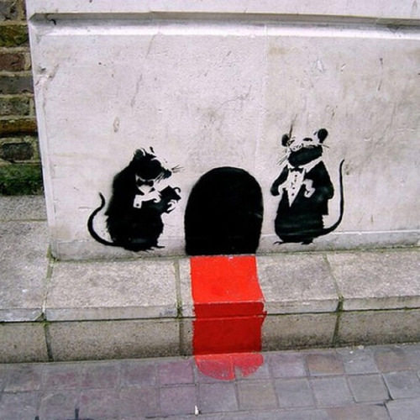

BANKSY CRITIQUE
Group 3
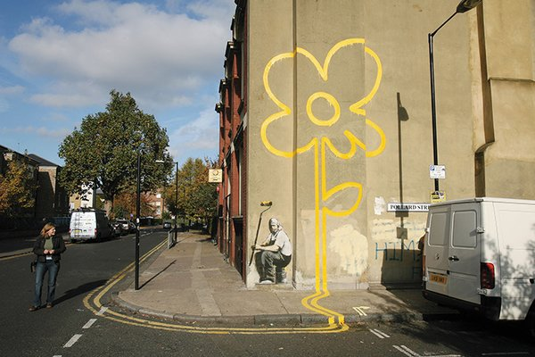

BANKSY CRITIQUE
As a group, analyze the photo you are given from the teacher with the following questions.

What words would you use to describe this painting? What other words might we use? How would you describe the lines in this picture? The shapes? The colors?

What observations can you make about it? How would you describe this painting to a person who could not see it?

What do you think other people would say about this work? Why do you think that?

Why do you think graffiti is illegal and not seen as an art form?

